**-Project Design Phase-ISolutionArchitecture**

|  |  |
| --- | --- |
| Date | 09 November 2022 |
| Team ID | PNT2022TMID48697 |
| ProjectName | Project-Web Phishing Detection |
| MaximumMarks | 4 Marks |

**SolutionArchitecture:**

Solution architecture is a complex process – with many sub-processes – that bridges the gapbetweenbusinessproblemsandtechnologysolutions.Itsgoalsareto:

* Findthebesttechsolutiontosolveexistingbusinessproblems.
* Describethestructure,characteristics, behavior,andother aspectsofthesoftwaretoprojectstakeholders.
* Definefeatures,developmentphases,andsolutionrequirements.
* Providespecificationsaccordingtowhichthesolutionisdefined,managed,anddelivered.

**SolutionArchitectureDiagram:**

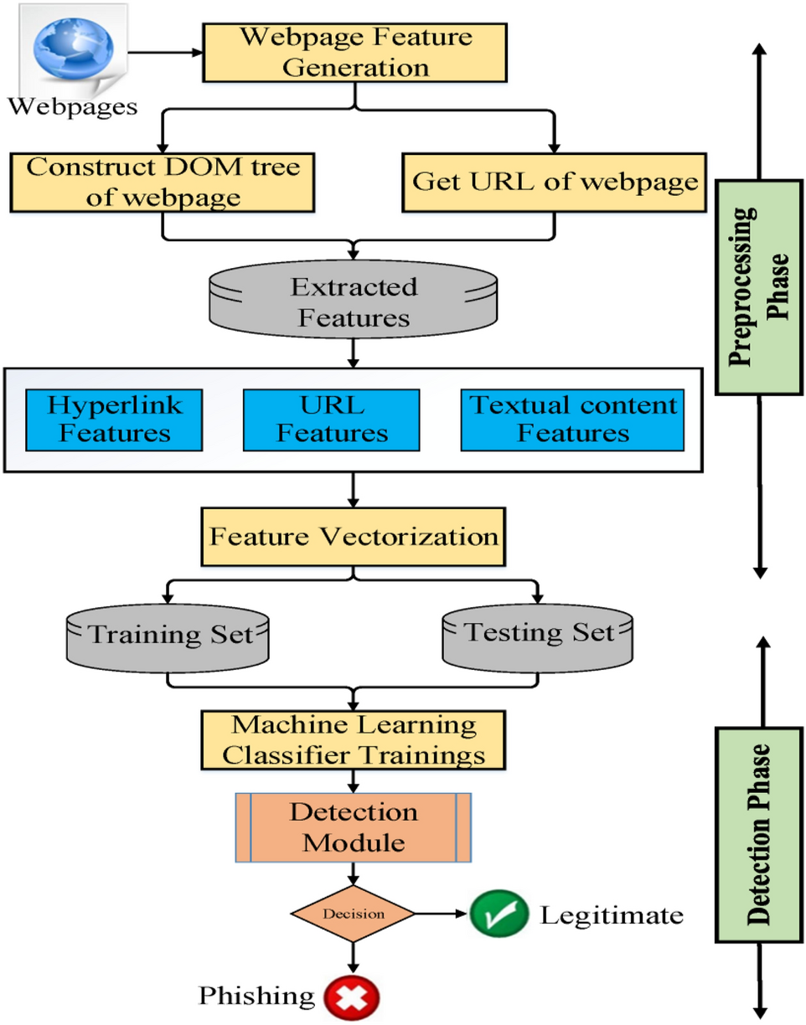

**ARCHITECTUREDIAGRAMFORWEBPHISHINGDETECTION**